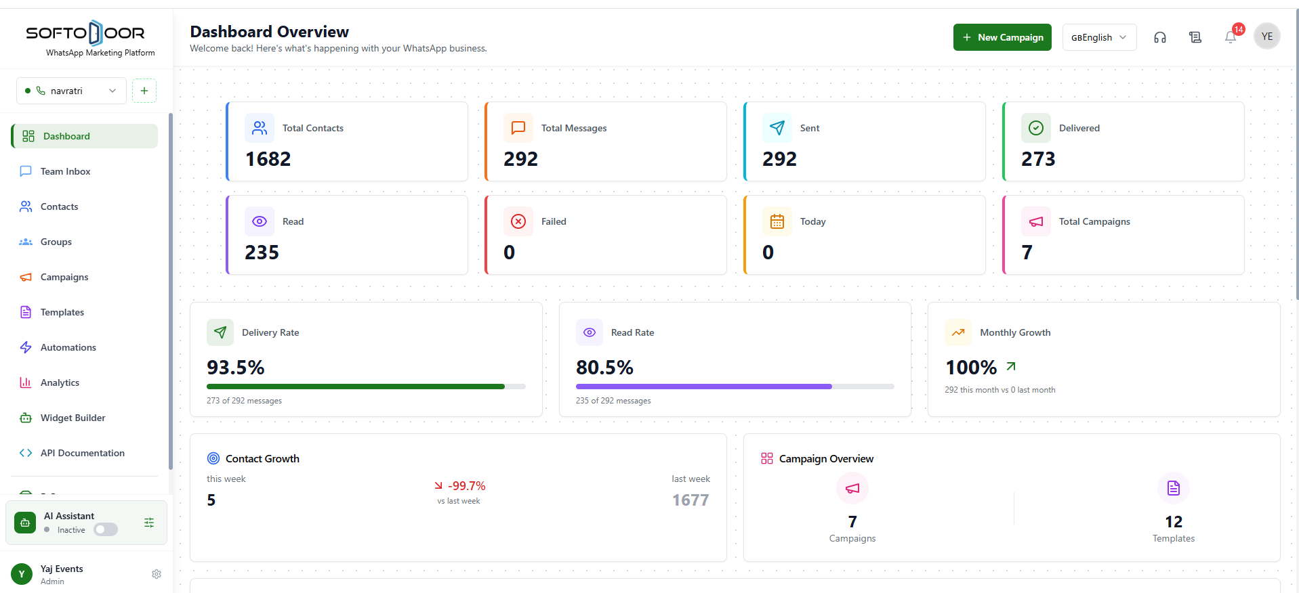
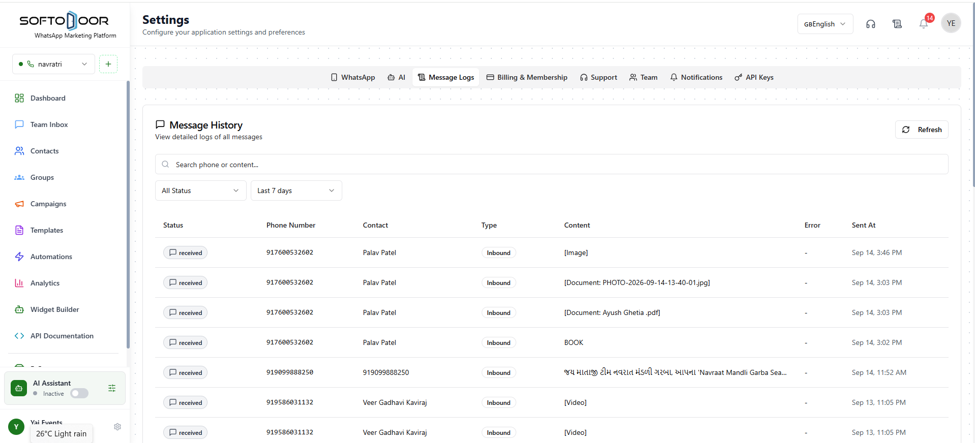
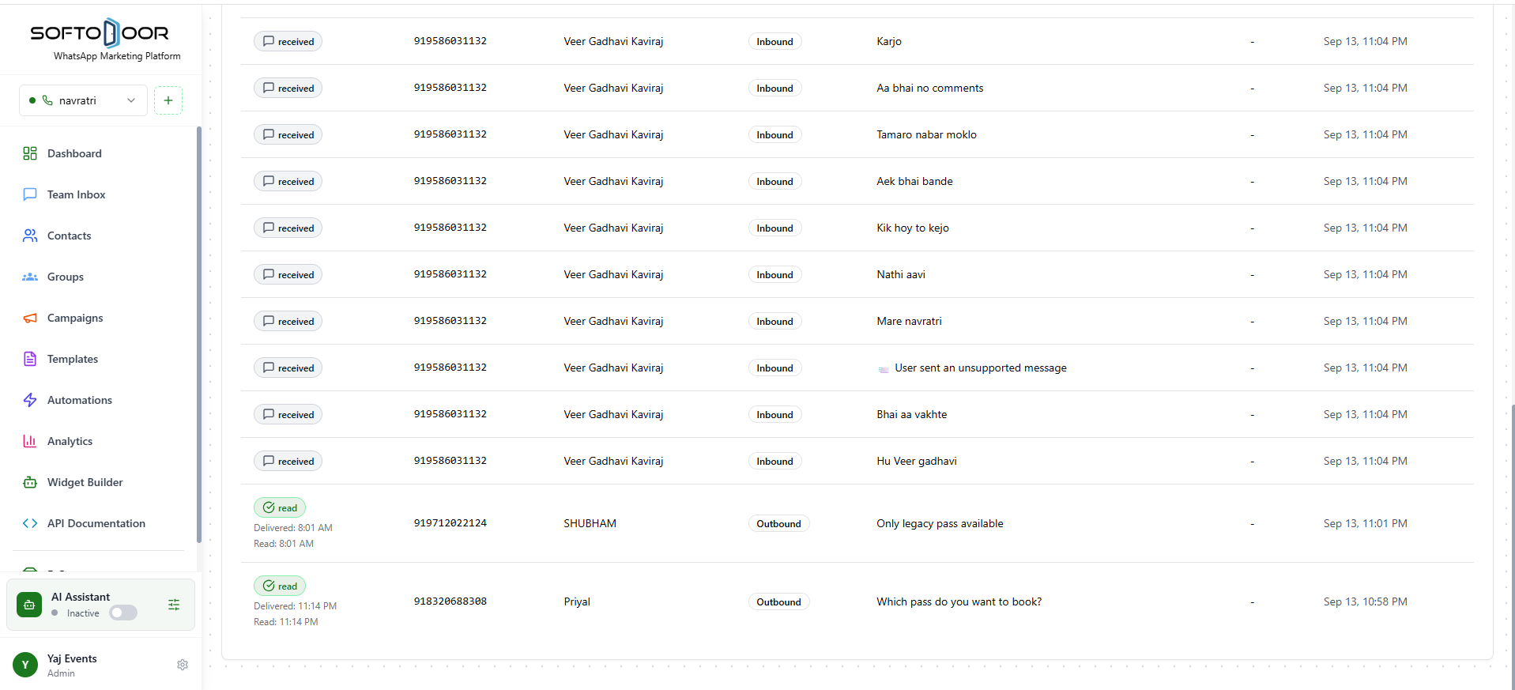
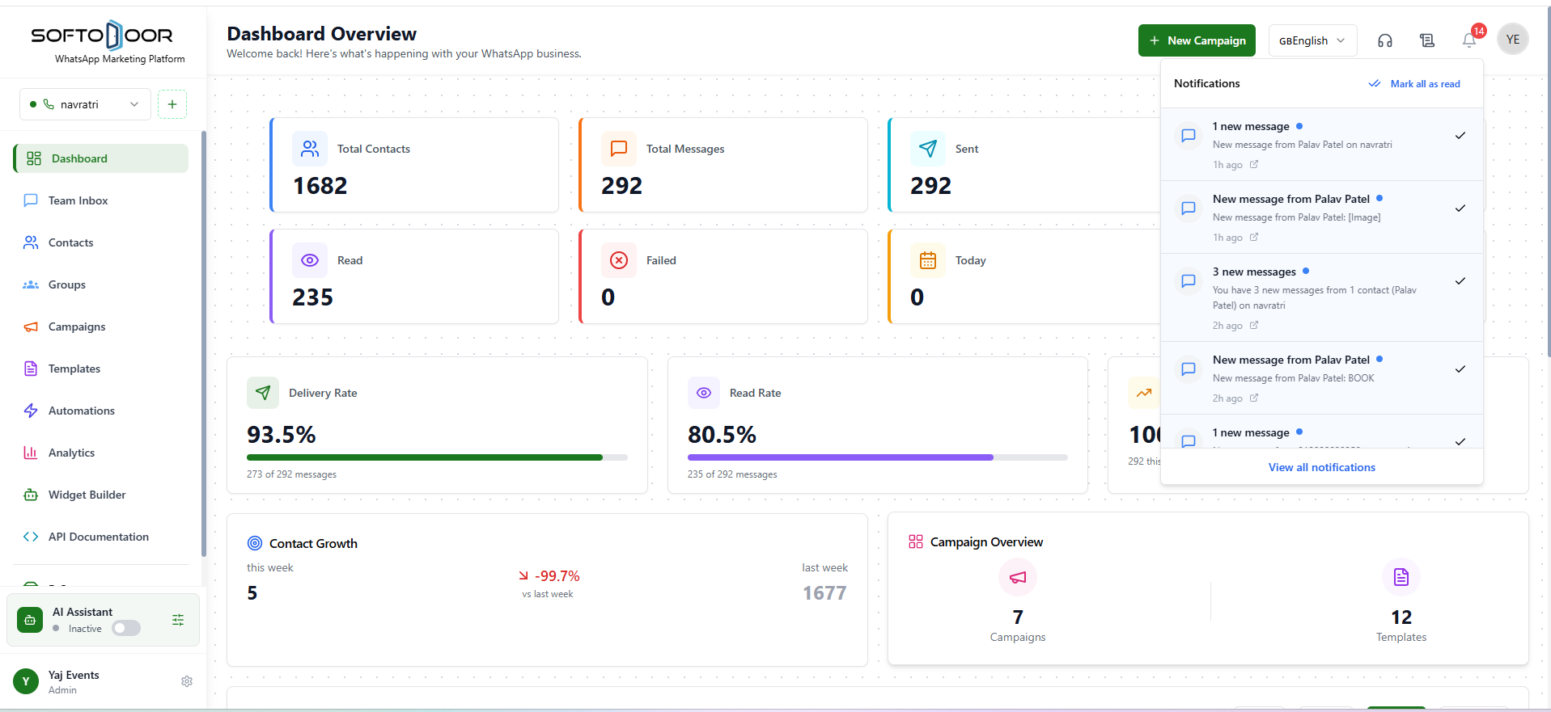
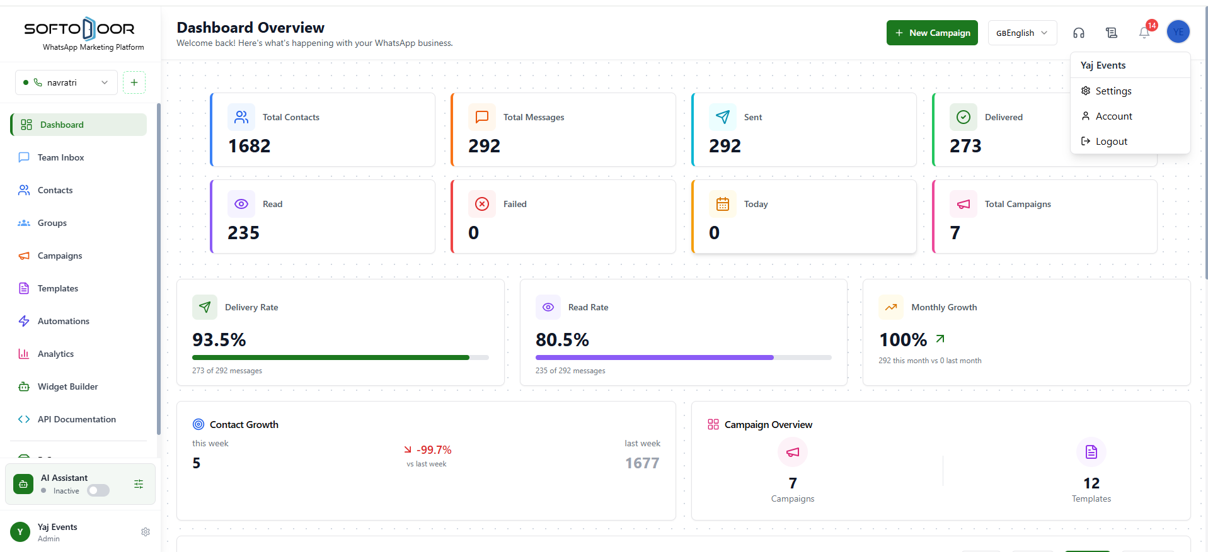

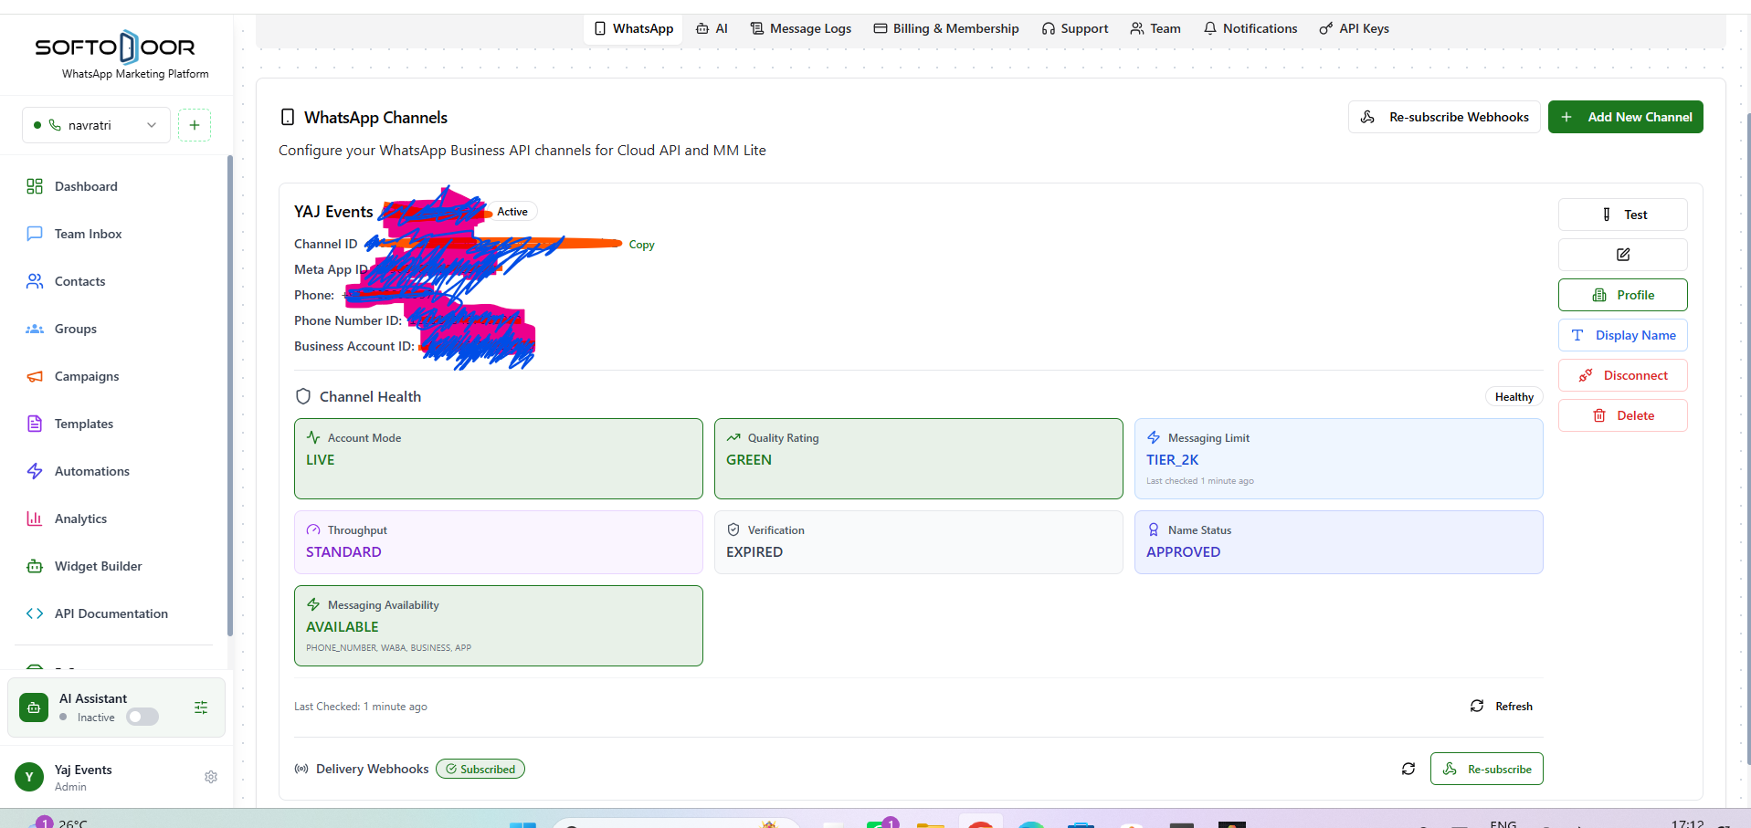
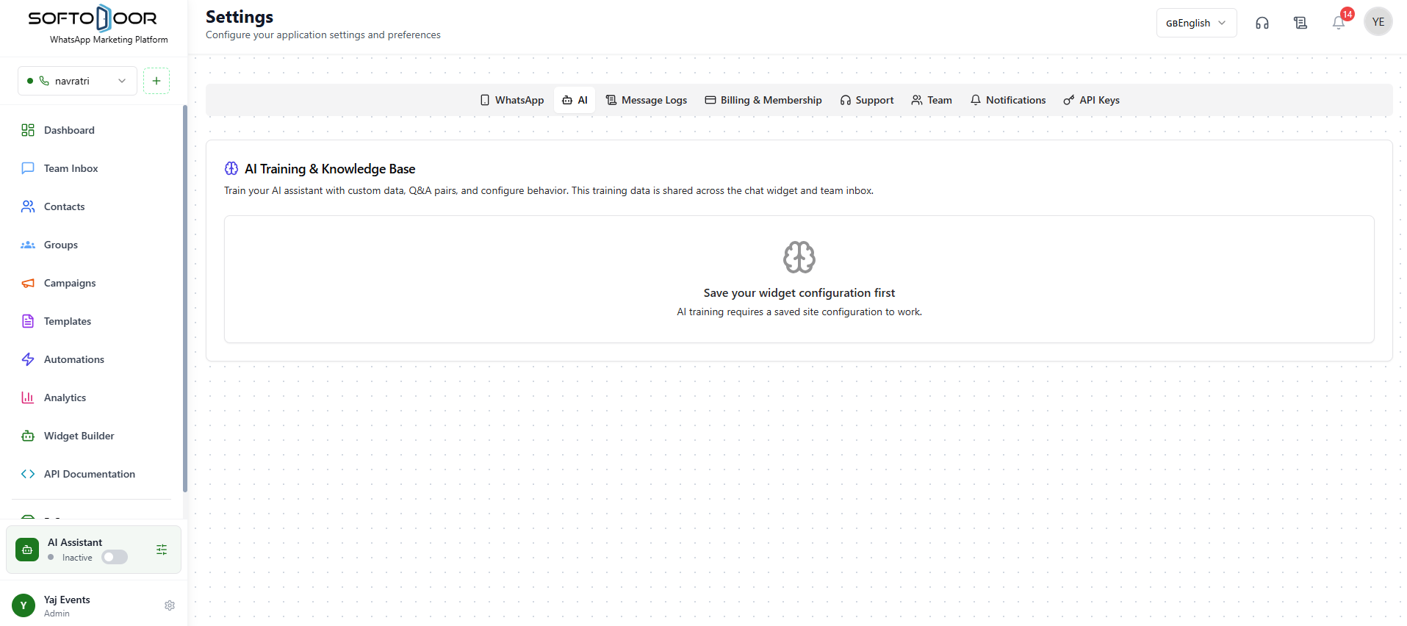
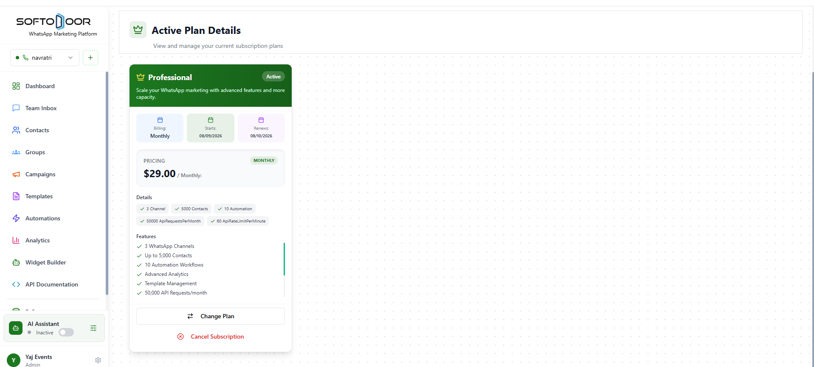
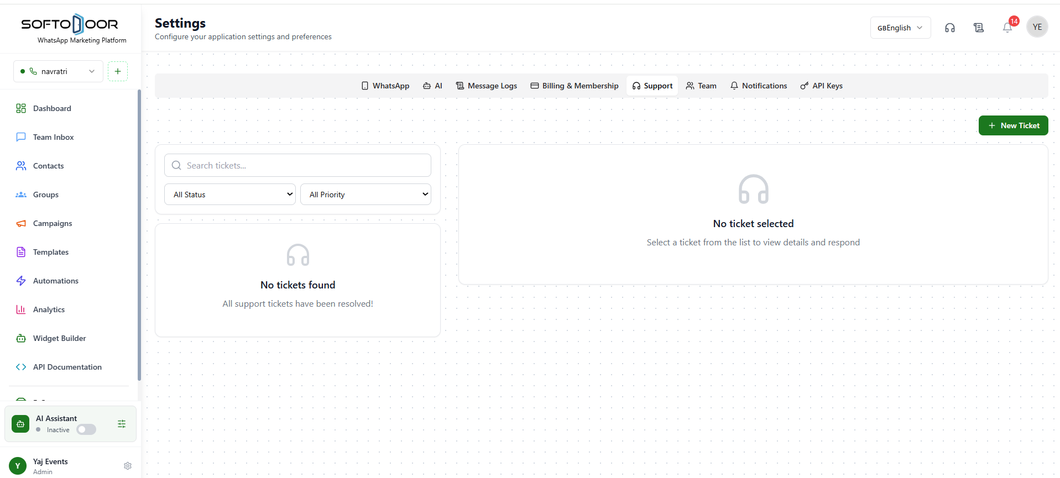
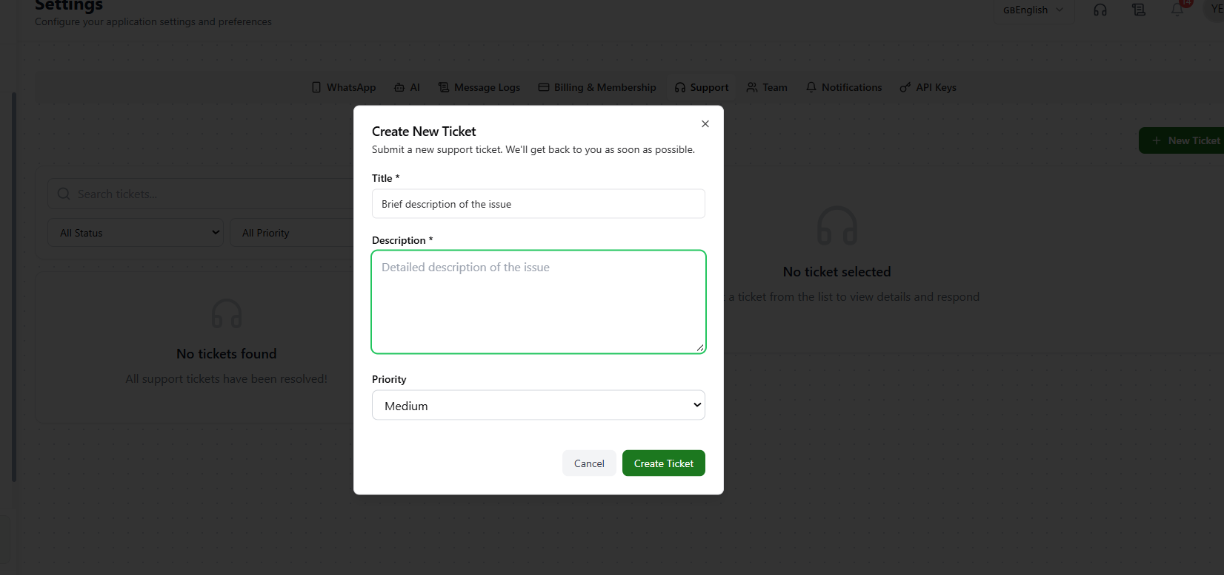
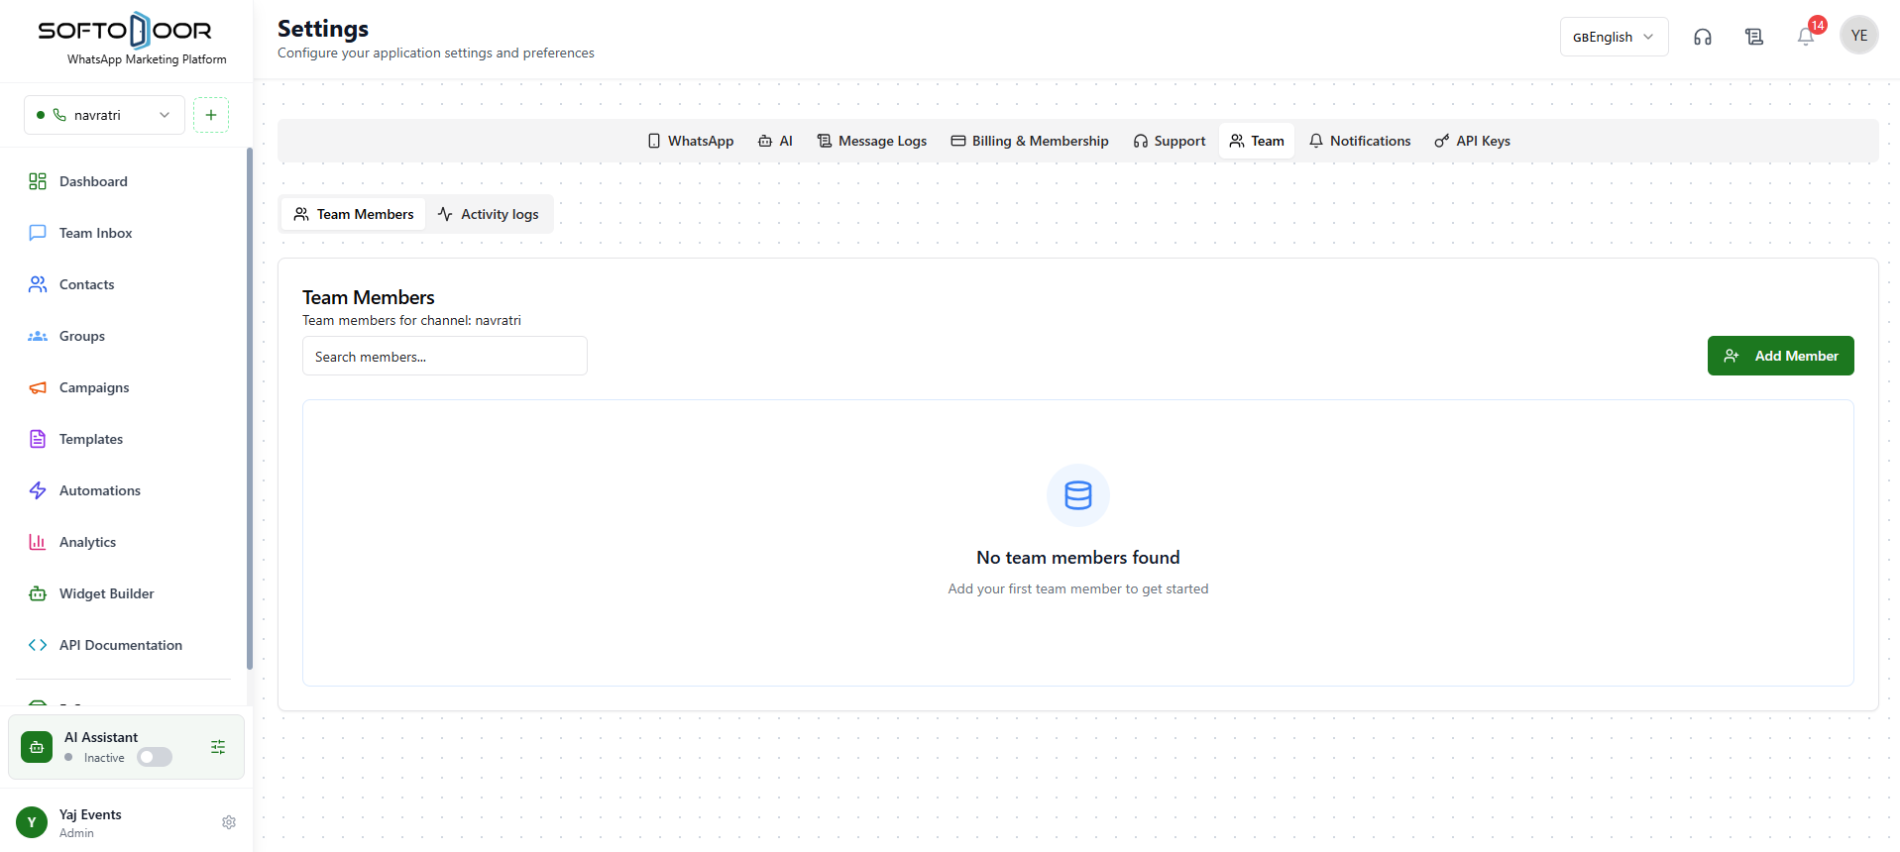

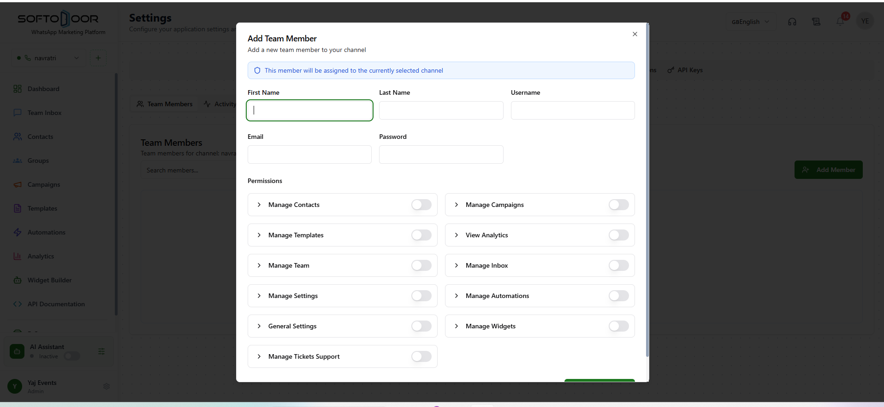
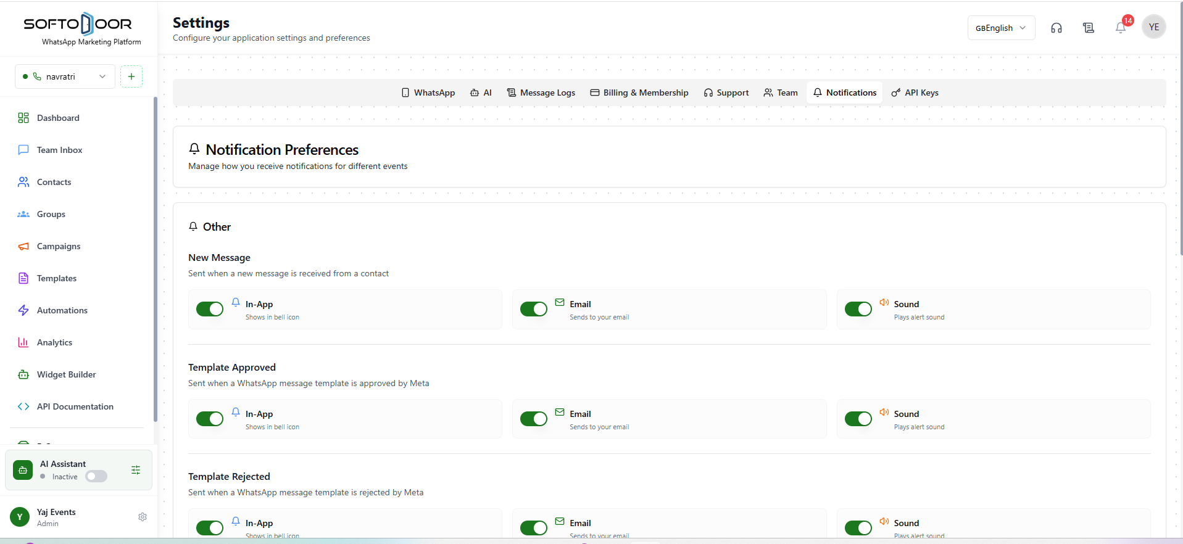
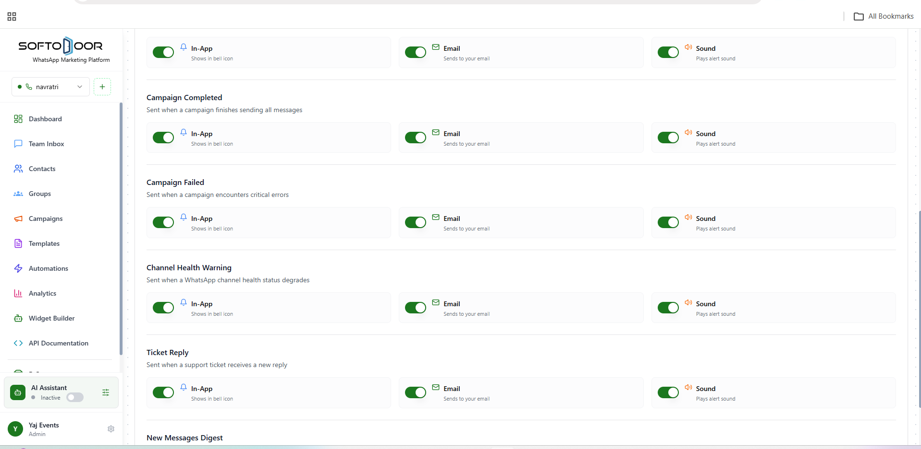
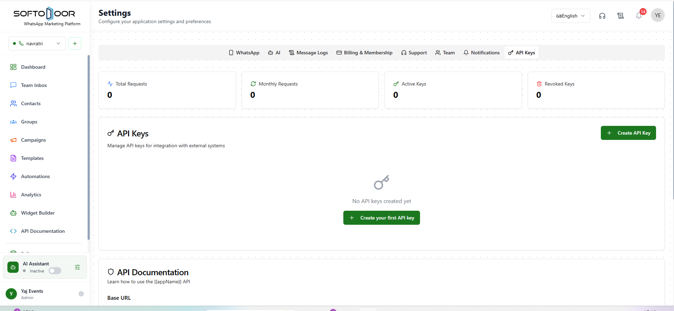
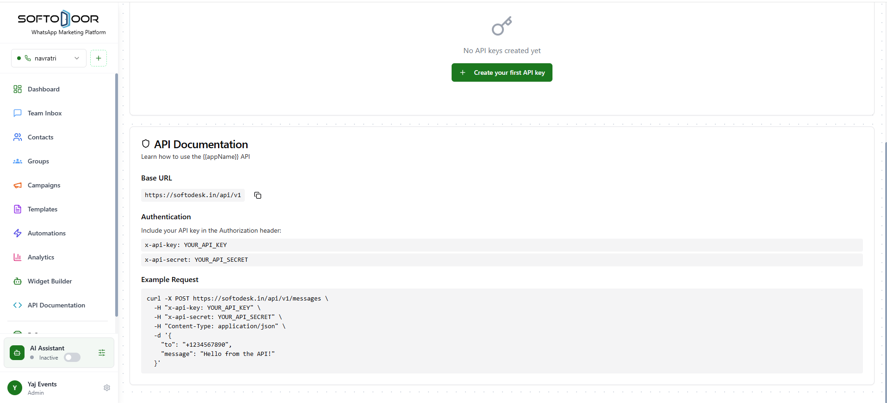
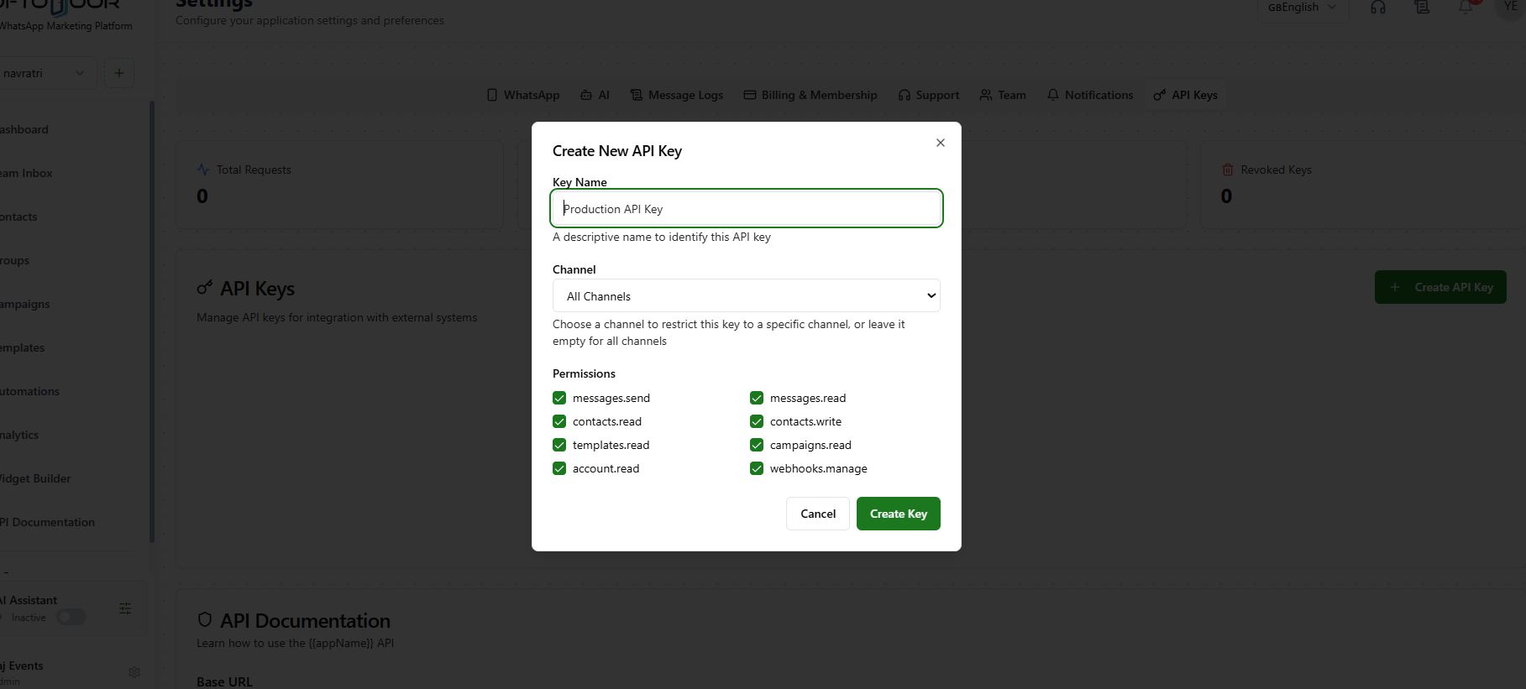
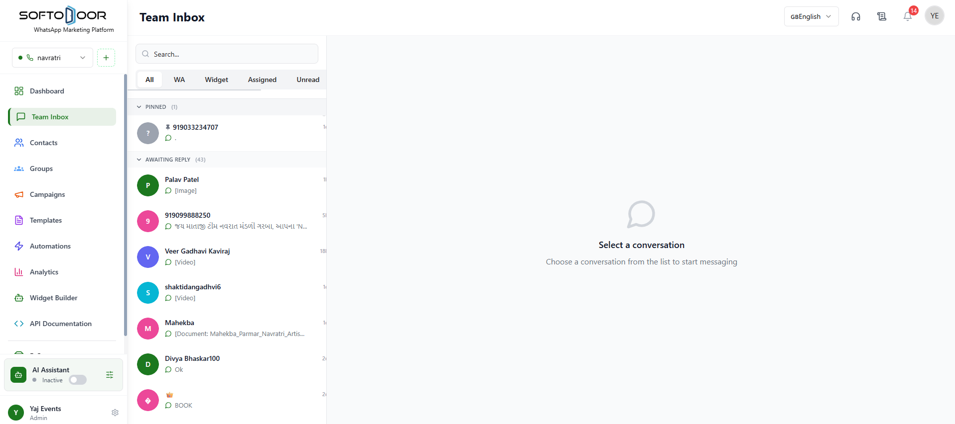
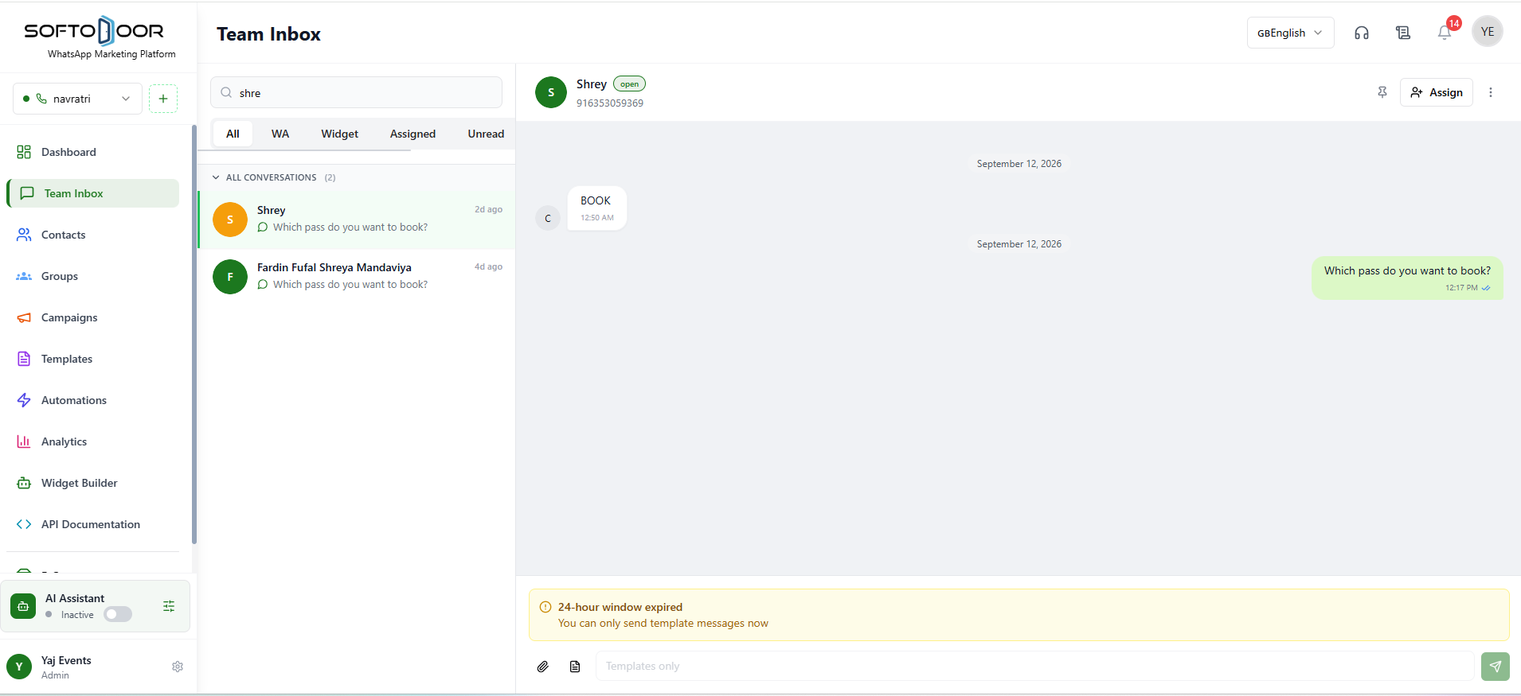
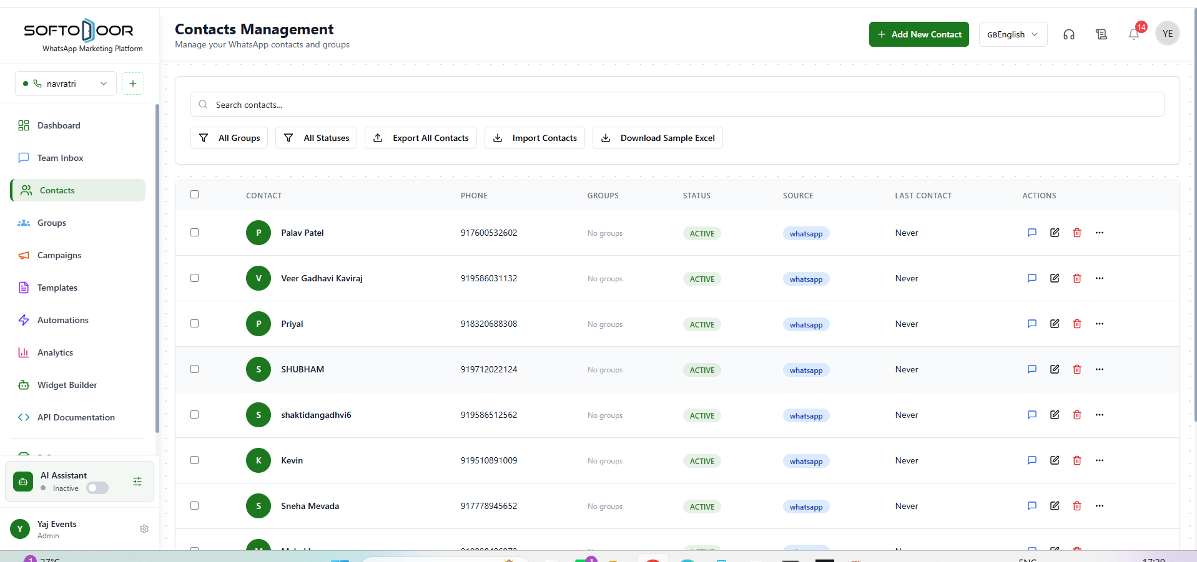
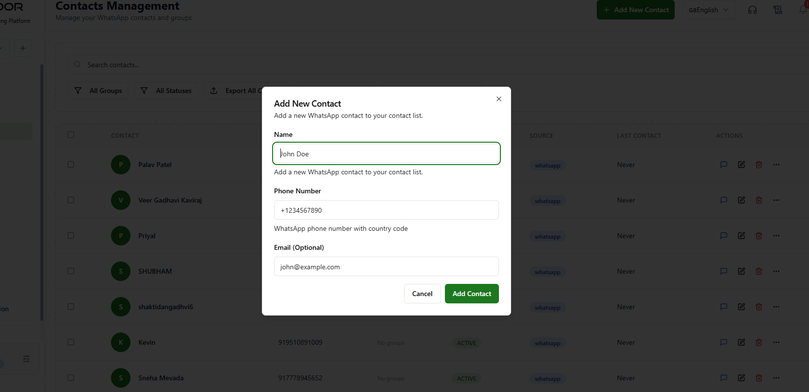
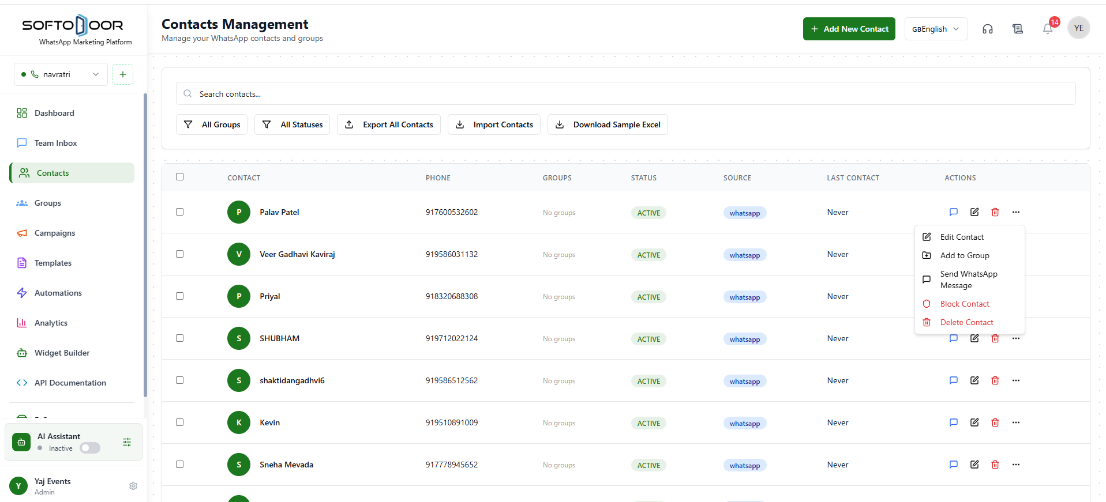
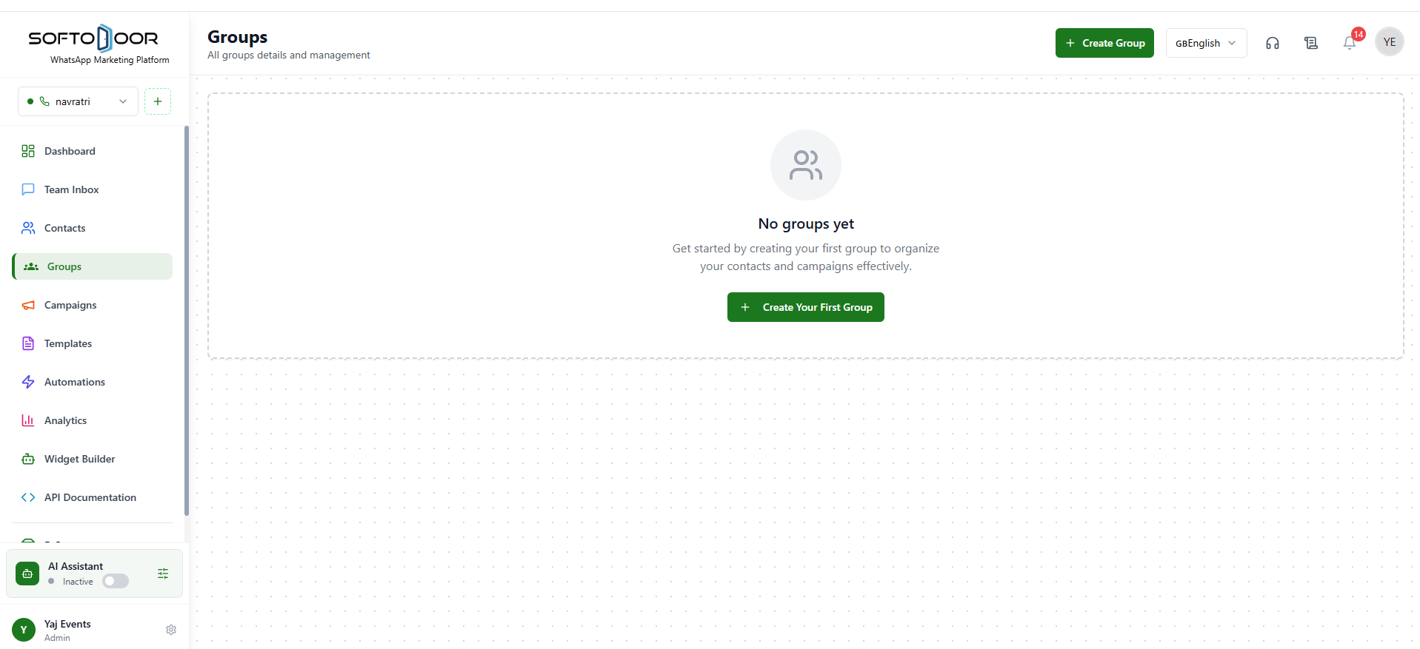
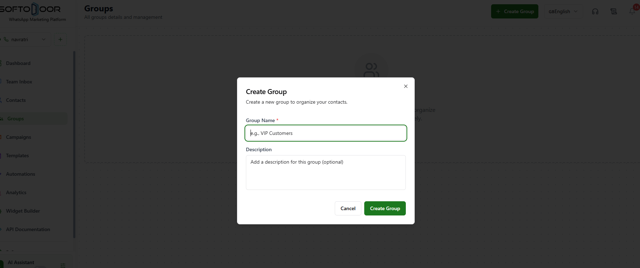
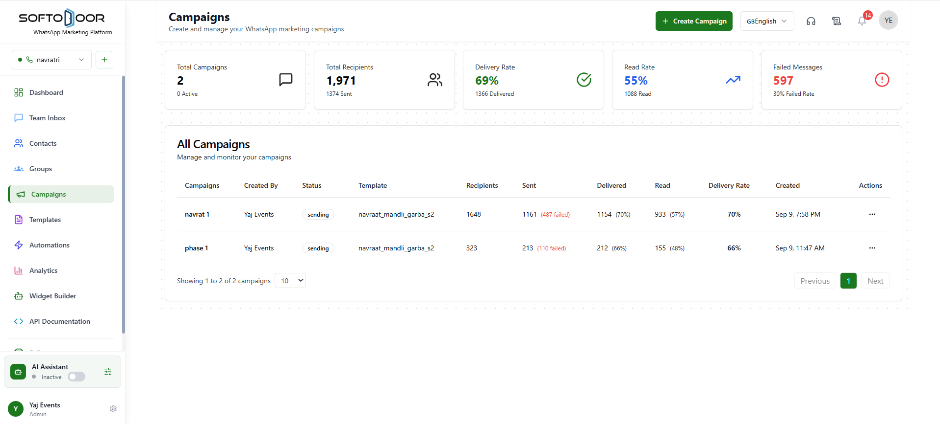
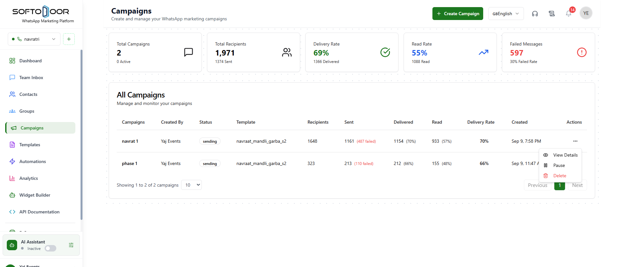
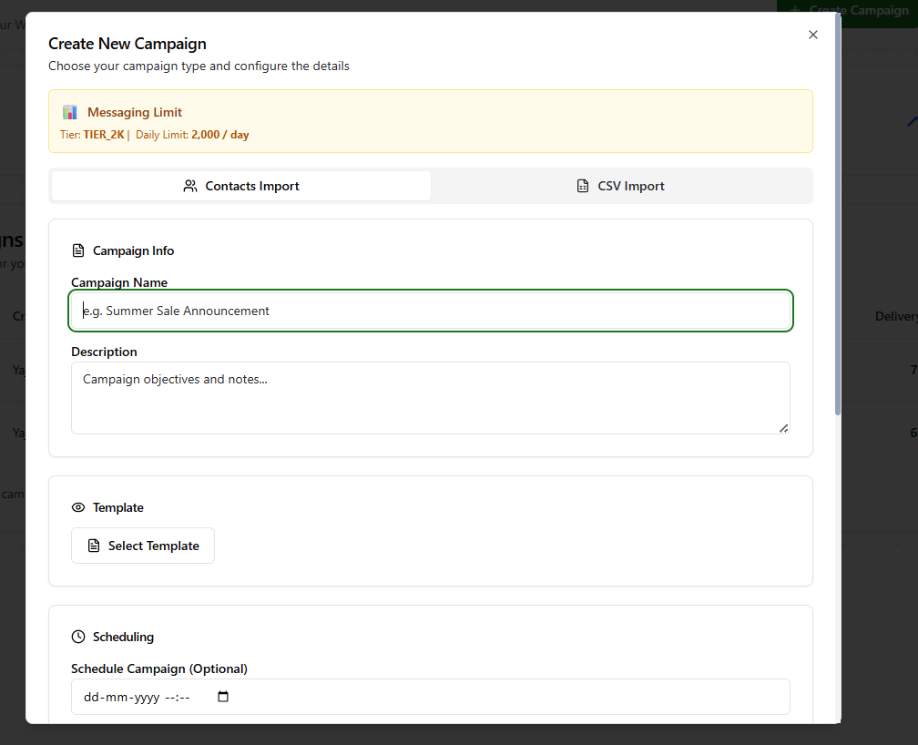
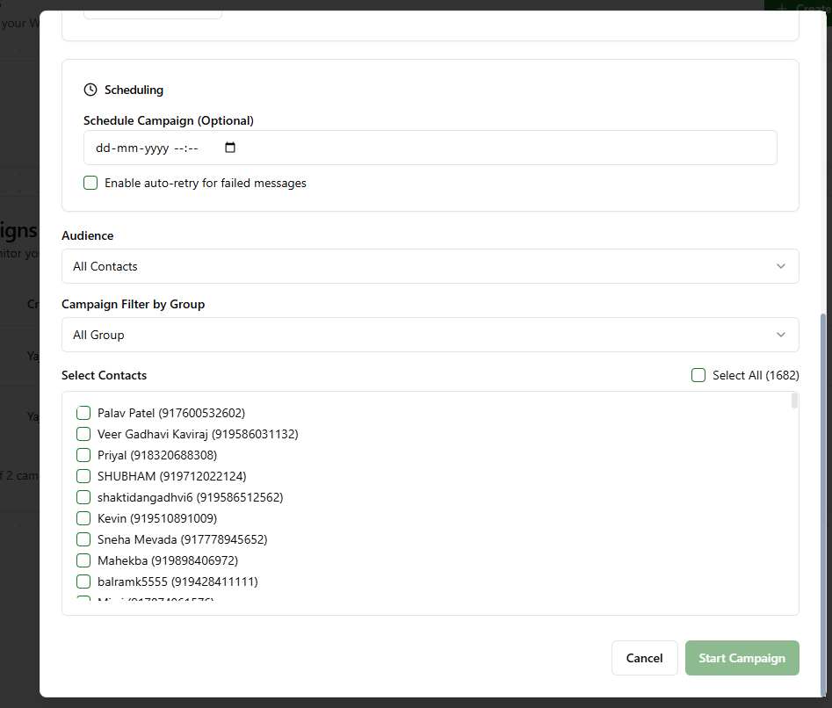
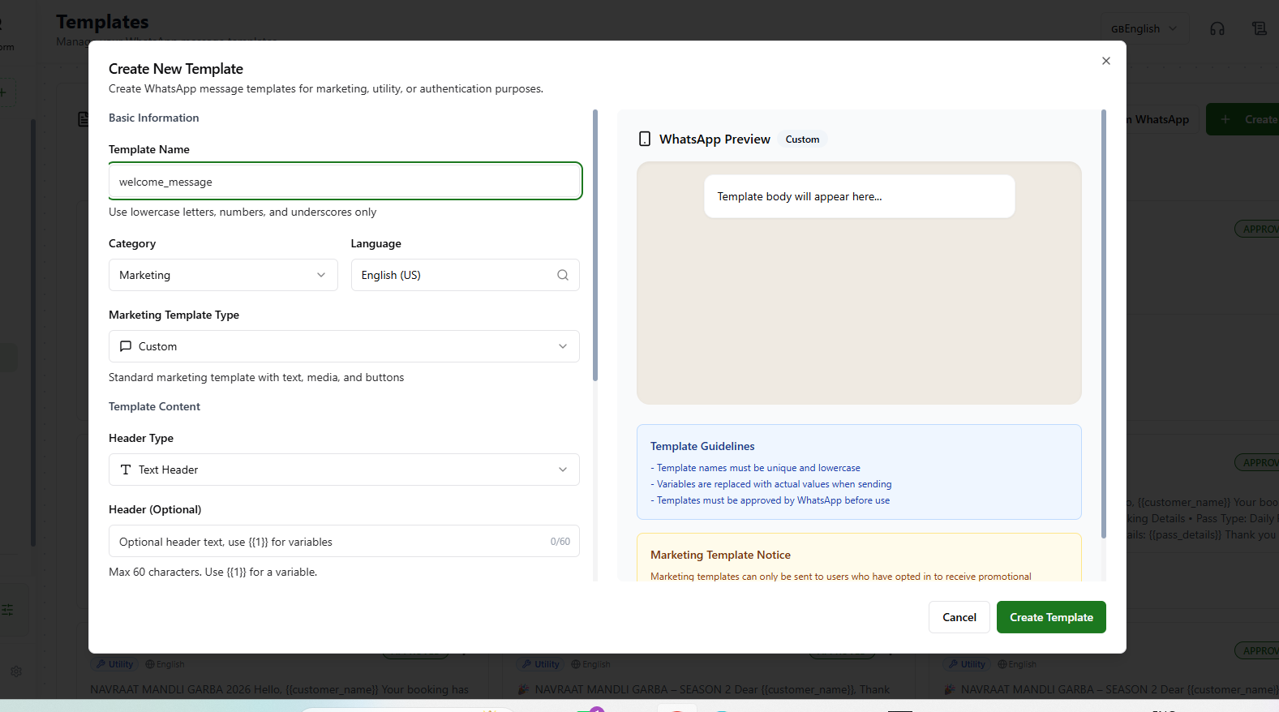
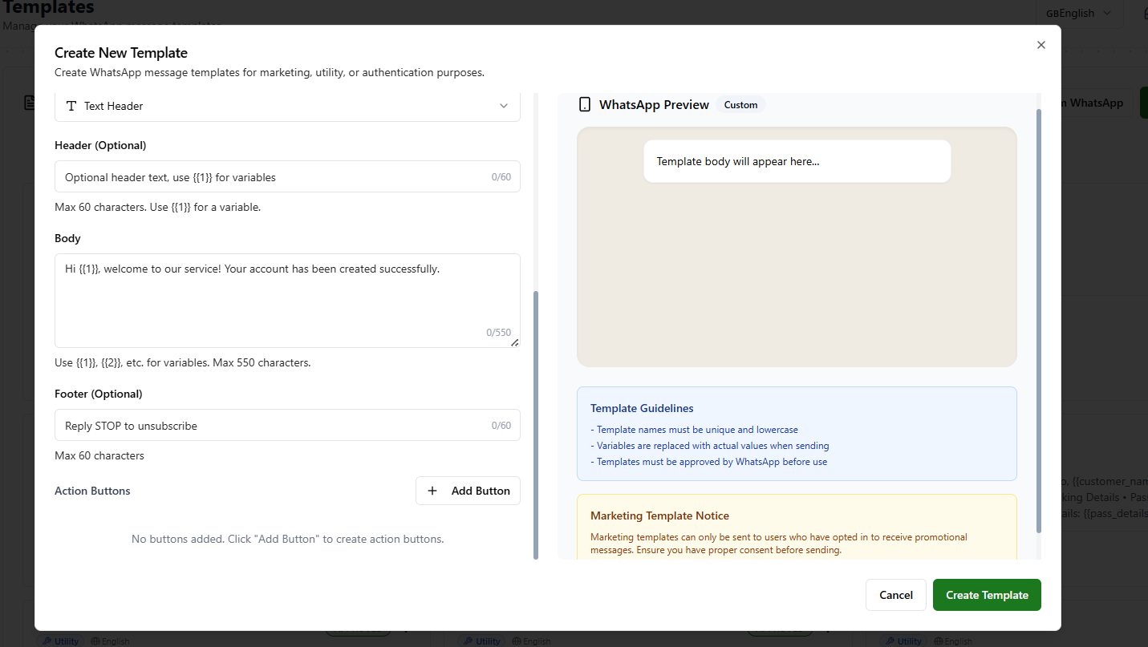
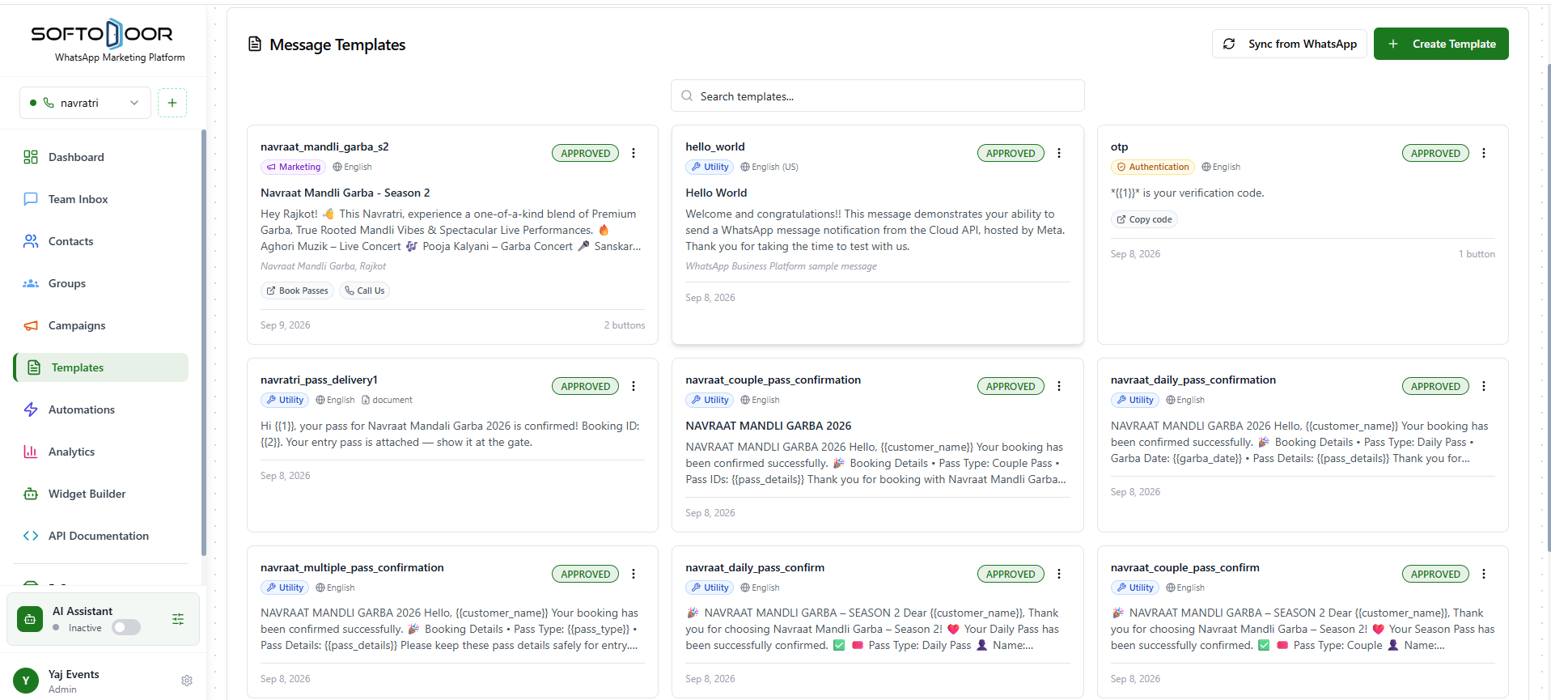
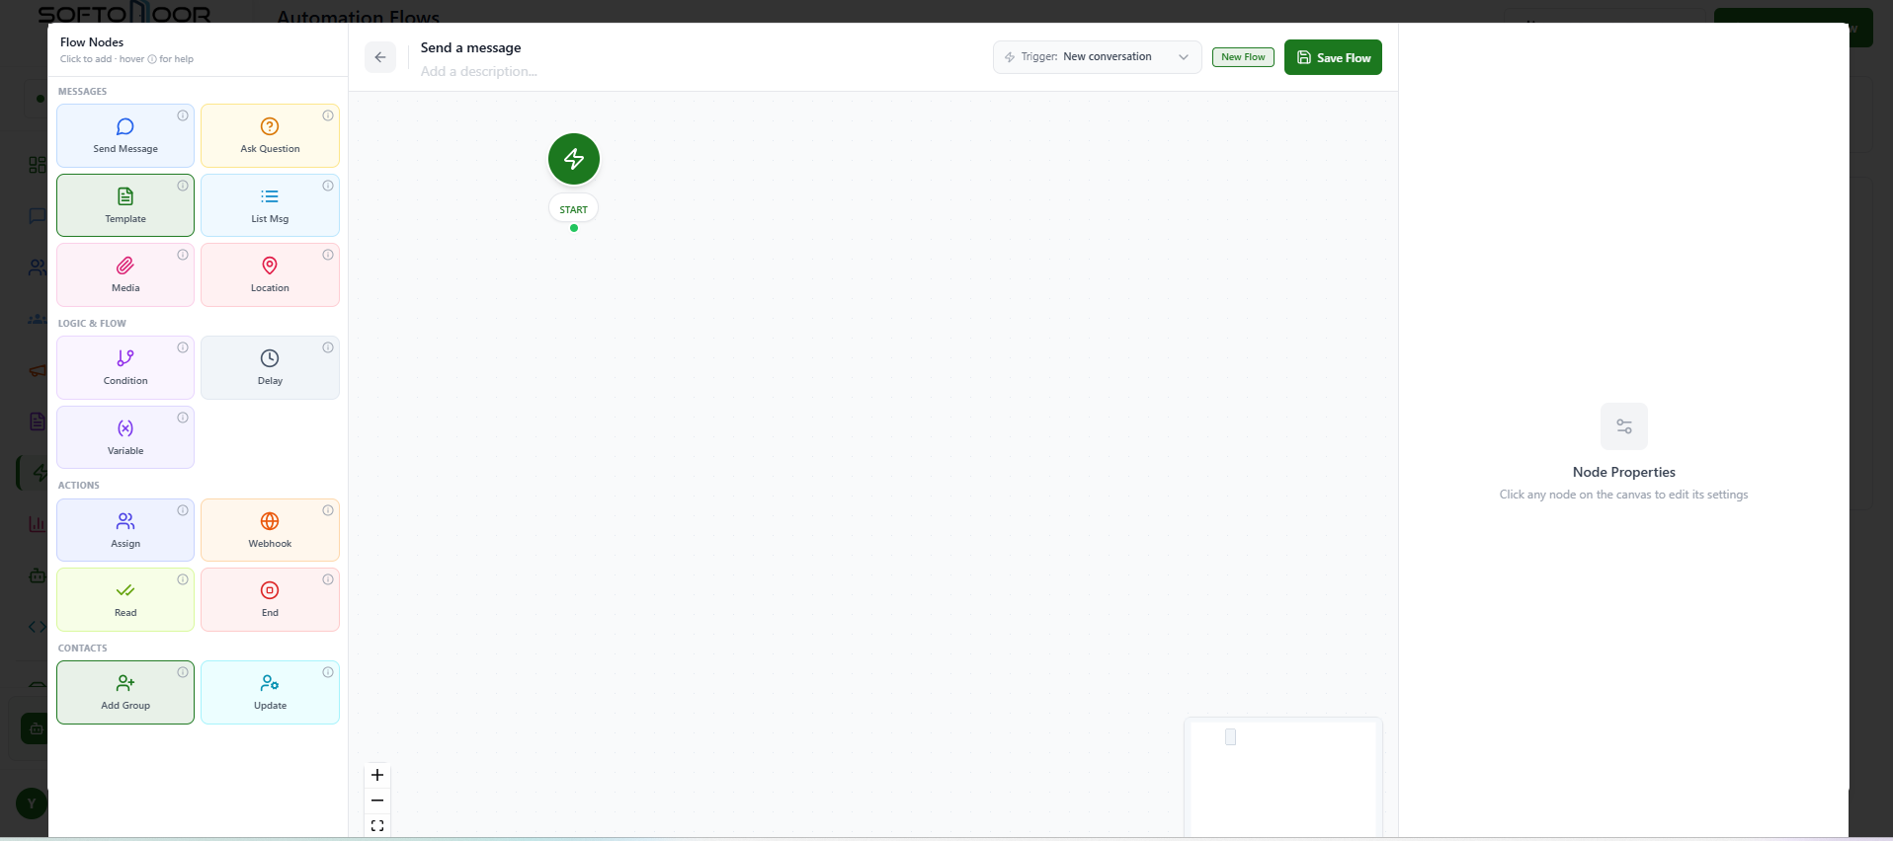
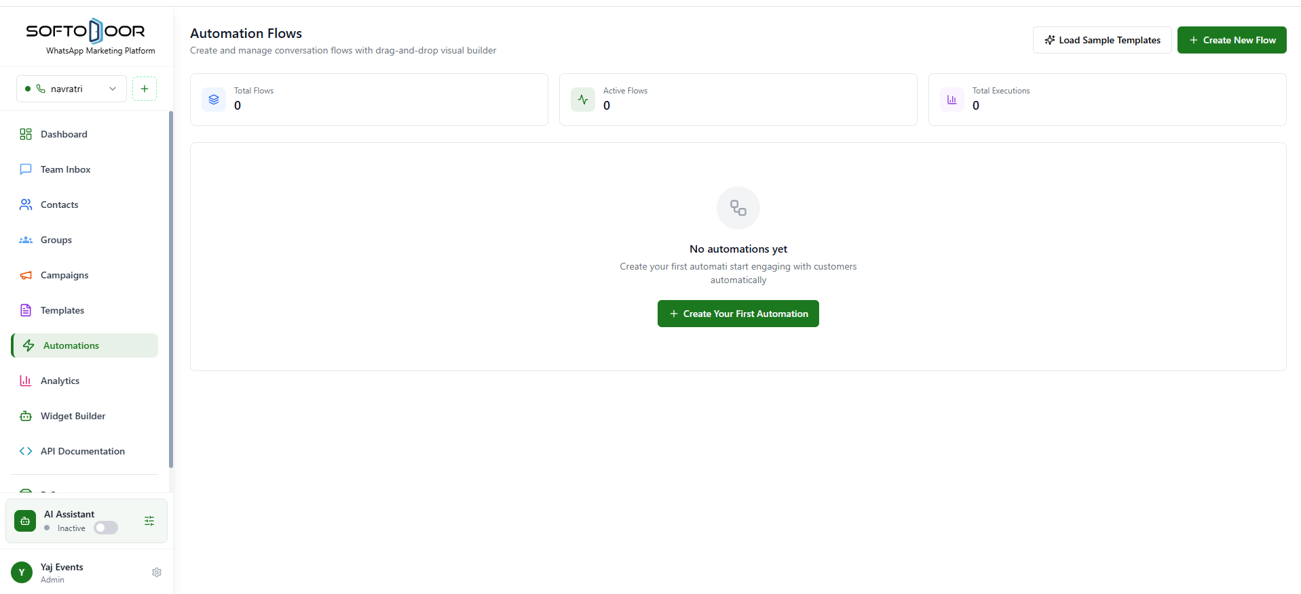
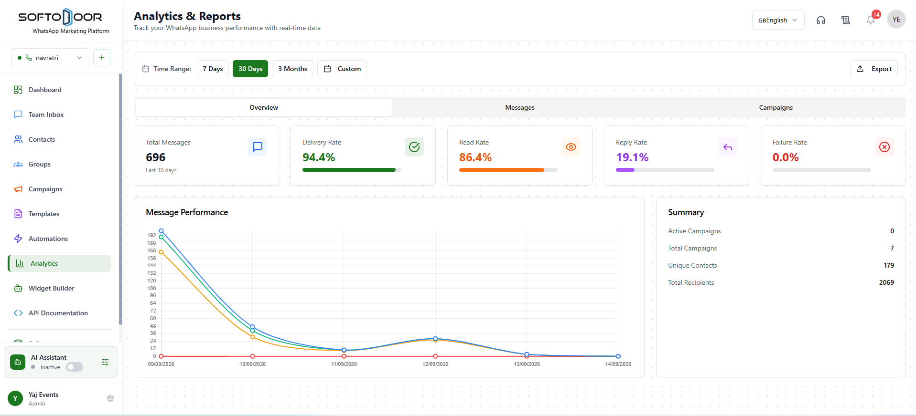
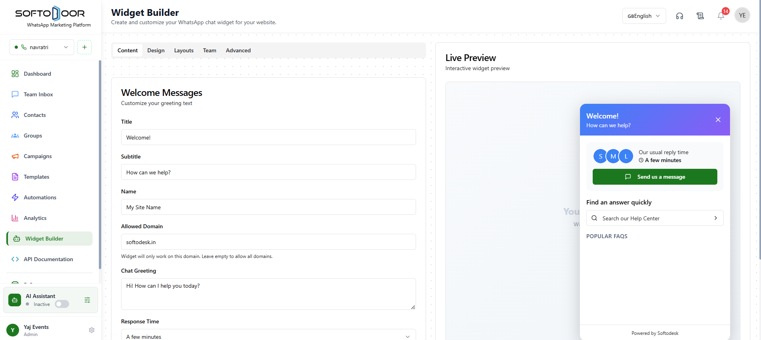
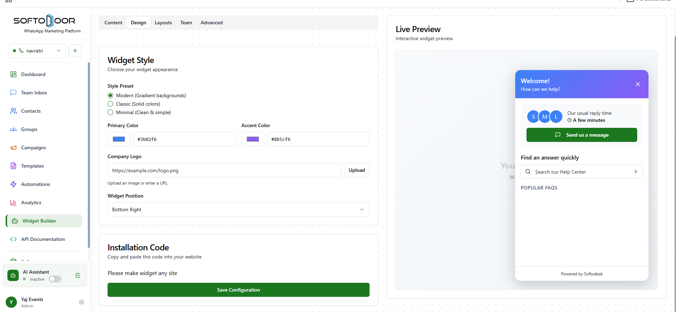
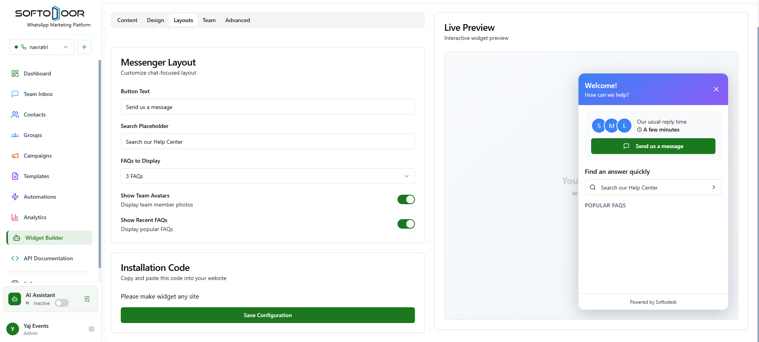
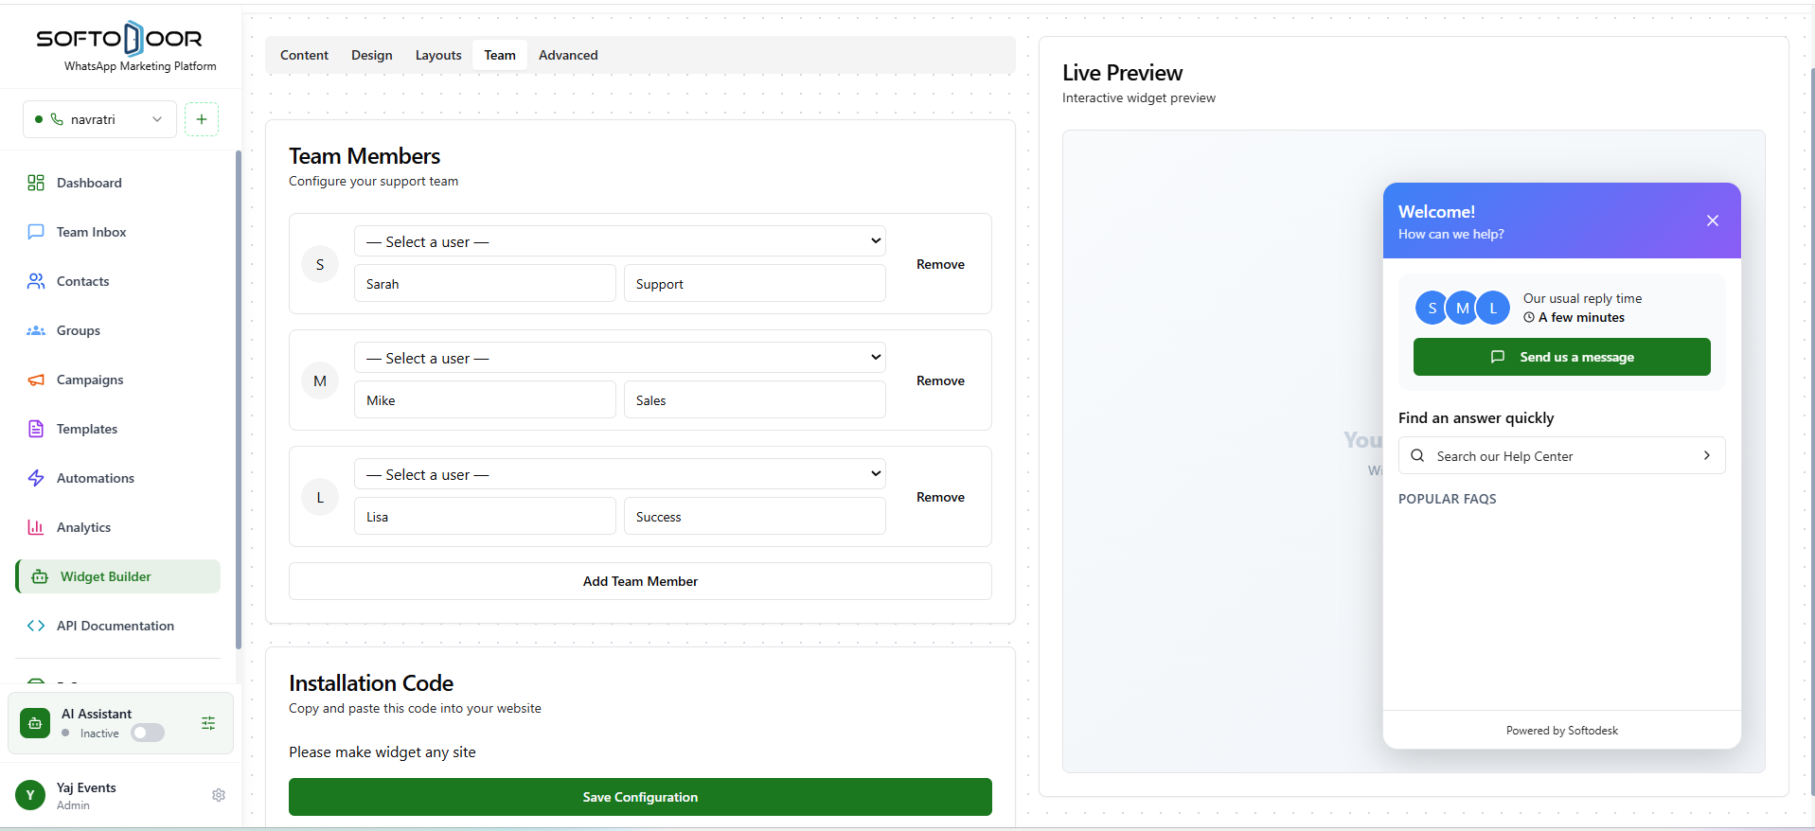
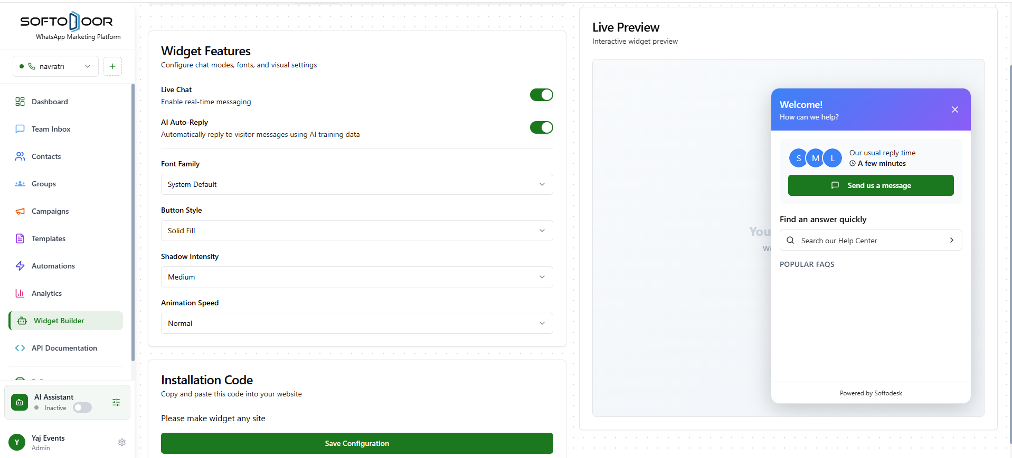
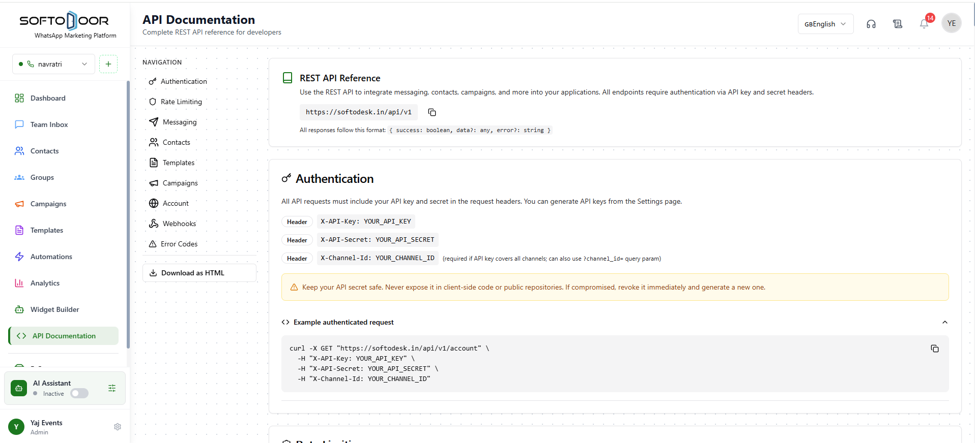

REST API Reference
Use the REST API to integrate messaging, contacts, campaigns, and more into your applications. All endpoints require authentication via API key and secret headers.
https://softodesk.in/api/v1
All responses follow this format: { success: boolean, data?: any, error?: string }
Authentication
All API requests must include your API key and secret in the request headers. You can generate API keys from the Settings page.
HeaderX-API-Key: YOUR_API_KEY
HeaderX-API-Secret: YOUR_API_SECRET
HeaderX-Channel-Id: YOUR_CHANNEL_ID(required if API key covers all channels; can also use ?channel_id= query param)
Keep your API secret safe. Never expose it in client-side code or public repositories. If compromised, revoke it immediately and generate a new one.

Example authenticated request
curl -X GET "https://softodesk.in/api/v1/account" \
-H "X-API-Key: YOUR_API_KEY" \
-H "X-API-Secret: YOUR_API_SECRET" \
-H "X-Channel-Id: YOUR_CHANNEL_ID"
Rate Limiting
API usage is rate-limited based on your subscription plan. Exceeding limits will result in a 429 status code response.
Monthly Request Limit
Total API requests allowed per calendar month, based on your subscription plan.
Per-Minute Rate Limit
Maximum number of requests allowed per minute to prevent abuse.
Response when rate limit is exceeded (HTTP 429)
{
"success": false,
"error": "Rate limit exceeded. Please try again later."
}
Messaging

POST

/api/v1/messages/template

Send a template message to a contact
Phone number format: digits only with country code, no spaces or + sign (e.g. 919876543210 for India, 14155552671 for US).

For templates with variables, pass a components array. Example with body variables:
{
"type": "body",
"parameters": [
{ "type": "text", "text": "John Doe" },
{ "type": "text", "text": "ORD-12345" }
]
}
Request Body
{
"to": "919876543210",
"templateName": "hello_world",
"language": "en_US",
"components": [
{
"type": "body",
"parameters": [
{
"type": "text",
"text": "John Doe"
},
{
"type": "text",
"text": "ORD-12345"
}
]
}
]
}
Response
{
"success": true,
"data": {
"messageId": "uuid-xxx",
"whatsappMessageId": "wamid.xxx",
"contactId": "uuid-xxx",
"conversationId": "uuid-xxx",
"status": "sent"
}
}
cURL
Copy cURL
curl -X POST "https://softodesk.in/api/v1/api/v1/messages/template" \
-H "X-API-Key: YOUR_API_KEY" \
-H "X-API-Secret: YOUR_API_SECRET" \
-H "X-Channel-Id: YOUR_CHANNEL_ID" \
-H "Content-Type: application/json" \
-d '{
"to": "919876543210",
"templateName": "hello_world",
"language": "en_US",
"components": [
{
"type": "body",
"parameters": [
{
"type": "text",
"text": "John Doe"
},
{
"type": "text",
"text": "ORD-12345"
}
]
}
]
}'

POST

/api/v1/messages/reply

Send a free-text reply within the 24-hour customer service window
This endpoint only works when the contact has sent you a message in the last 24 hours (WhatsApp's customer service window). If the window has expired, use the template message endpoint instead.

Phone number format: digits only with country code (e.g. 919876543210).
Request Body
{
"to": "919876543210",
"message": "Hello! Your order has been shipped."
}
Response
{
"success": true,
"data": {
"messageId": "uuid-xxx",
"whatsappMessageId": "wamid.xxx",
"status": "sent"
}
}
cURL
Copy cURL
curl -X POST "https://softodesk.in/api/v1/api/v1/messages/reply" \
-H "X-API-Key: YOUR_API_KEY" \
-H "X-API-Secret: YOUR_API_SECRET" \
-H "X-Channel-Id: YOUR_CHANNEL_ID" \
-H "Content-Type: application/json" \
-d '{
"to": "919876543210",
"message": "Hello! Your order has been shipped."
}'

GET

/api/v1/messages/:contactPhone

Get message history for a contact
Replace :contactPhone with the contact's phone number (digits only, with country code).
Query Parameters
?limit=50&offset=0
Response
{
"success": true,
"data": {
"messages": [],
"total": 0,
"limit": 50,
"offset": 0
}
}
cURL
Copy cURL
curl -X GET "https://softodesk.in/api/v1/api/v1/messages/:contactPhone?limit=50&offset=0" \
-H "X-API-Key: YOUR_API_KEY" \
-H "X-API-Secret: YOUR_API_SECRET" \
-H "X-Channel-Id: YOUR_CHANNEL_ID"

GET

/api/v1/messages/status/:messageId

Get delivery status of a specific message
Replace :messageId with the messageId returned when the message was sent.
Response
{
"success": true,
"data": {
"id": "uuid-xxx",
"whatsappMessageId": "wamid.xxx",
"status": "delivered",
"deliveredAt": "2024-01-01T12:00:00Z",
"readAt": null,
"errorCode": null,
"errorMessage": null,
"createdAt": "2024-01-01T11:59:00Z"
}
}
cURL
Copy cURL
curl -X GET "https://softodesk.in/api/v1/api/v1/messages/status/:messageId" \
-H "X-API-Key: YOUR_API_KEY" \
-H "X-API-Secret: YOUR_API_SECRET" \
-H "X-Channel-Id: YOUR_CHANNEL_ID"
Contacts

GET

/api/v1/contacts

List all contacts with optional filters
Query Parameters
?search=John&limit=50&offset=0&groupId=xxx
Response
{
"success": true,
"data": {
"contacts": [],
"total": 0
}
}
cURL
Copy cURL
curl -X GET "https://softodesk.in/api/v1/api/v1/contacts?search=John&limit=50&offset=0&groupId=xxx" \
-H "X-API-Key: YOUR_API_KEY" \
-H "X-API-Secret: YOUR_API_SECRET" \
-H "X-Channel-Id: YOUR_CHANNEL_ID"

POST

/api/v1/contacts

Create a new contact
Phone number must include country code, digits only (e.g. 919876543210). Returns 409 if the contact already exists.
Request Body
{
"phone": "919876543210",
"name": "John Doe",
"email": "john@example.com"
}
Response
{
"success": true,
"data": {
"id": "uuid-xxx",
"phone": "919876543210",
"name": "John Doe"
}
}
cURL
Copy cURL
curl -X POST "https://softodesk.in/api/v1/api/v1/contacts" \
-H "X-API-Key: YOUR_API_KEY" \
-H "X-API-Secret: YOUR_API_SECRET" \
-H "X-Channel-Id: YOUR_CHANNEL_ID" \
-H "Content-Type: application/json" \
-d '{
"phone": "919876543210",
"name": "John Doe",
"email": "john@example.com"
}'

PUT

/api/v1/contacts/:id

Update an existing contact's name or email
Request Body
{
"name": "John Updated",
"email": "john.new@example.com"
}
Response
{
"success": true,
"data": {
"id": "uuid-xxx",
"name": "John Updated"
}
}
cURL
Copy cURL
curl -X PUT "https://softodesk.in/api/v1/api/v1/contacts/:id" \
-H "X-API-Key: YOUR_API_KEY" \
-H "X-API-Secret: YOUR_API_SECRET" \
-H "X-Channel-Id: YOUR_CHANNEL_ID" \
-H "Content-Type: application/json" \
-d '{
"name": "John Updated",
"email": "john.new@example.com"
}'

DELETE

/api/v1/contacts/:id

Delete a contact permanently
Response
{
"success": true,
"data": {
"message": "Contact deleted successfully"
}
}
cURL
Copy cURL
curl -X DELETE "https://softodesk.in/api/v1/api/v1/contacts/:id" \
-H "X-API-Key: YOUR_API_KEY" \
-H "X-API-Secret: YOUR_API_SECRET" \
-H "X-Channel-Id: YOUR_CHANNEL_ID"

GET

/api/v1/contacts/groups

List all contact groups
Response
{
"success": true,
"data": []
}
cURL
Copy cURL
curl -X GET "https://softodesk.in/api/v1/api/v1/contacts/groups" \
-H "X-API-Key: YOUR_API_KEY" \
-H "X-API-Secret: YOUR_API_SECRET" \
-H "X-Channel-Id: YOUR_CHANNEL_ID"

POST

/api/v1/contacts/groups/:groupId/add

Add a contact to a group
Request Body
{
"contactId": "uuid-xxx"
}
Response
{
"success": true,
"data": {
"message": "Contact added to group"
}
}
cURL
Copy cURL
curl -X POST "https://softodesk.in/api/v1/api/v1/contacts/groups/:groupId/add" \
-H "X-API-Key: YOUR_API_KEY" \
-H "X-API-Secret: YOUR_API_SECRET" \
-H "X-Channel-Id: YOUR_CHANNEL_ID" \
-H "Content-Type: application/json" \
-d '{
"contactId": "uuid-xxx"
}'

POST

/api/v1/contacts/groups/:groupId/remove

Remove a contact from a group
Request Body
{
"contactId": "uuid-xxx"
}
Response
{
"success": true,
"data": {
"message": "Contact removed from group"
}
}
cURL
Copy cURL
curl -X POST "https://softodesk.in/api/v1/api/v1/contacts/groups/:groupId/remove" \
-H "X-API-Key: YOUR_API_KEY" \
-H "X-API-Secret: YOUR_API_SECRET" \
-H "X-Channel-Id: YOUR_CHANNEL_ID" \
-H "Content-Type: application/json" \
-d '{
"contactId": "uuid-xxx"
}'
Templates

GET

/api/v1/templates

List all message templates for the channel
Filter by status to get only approved templates ready for sending. Common status values: APPROVED, PENDING, REJECTED.
Query Parameters
?status=APPROVED
Response
{
"success": true,
"data": [
{
"id": "uuid-xxx",
"name": "hello_world",
"status": "APPROVED",
"language": "en_US",
"category": "MARKETING"
}
]
}
cURL
Copy cURL
curl -X GET "https://softodesk.in/api/v1/api/v1/templates?status=APPROVED" \
-H "X-API-Key: YOUR_API_KEY" \
-H "X-API-Secret: YOUR_API_SECRET" \
-H "X-Channel-Id: YOUR_CHANNEL_ID"
Campaigns

GET

/api/v1/campaigns

List all campaigns with optional filters
Query Parameters
?status=completed&limit=10&offset=0
Response
{
"success": true,
"data": {
"campaigns": [],
"total": 0,
"limit": 10,
"offset": 0
}
}
cURL
Copy cURL
curl -X GET "https://softodesk.in/api/v1/api/v1/campaigns?status=completed&limit=10&offset=0" \
-H "X-API-Key: YOUR_API_KEY" \
-H "X-API-Secret: YOUR_API_SECRET" \
-H "X-Channel-Id: YOUR_CHANNEL_ID"
Account

GET

/api/v1/account

Get channel information and API key details
Response
{
"success": true,
"data": {
"userId": "uuid-xxx",
"channel": {
"id": "uuid-xxx",
"name": "My Channel",
"phoneNumber": "+919876543210",
"isActive": true,
"healthStatus": "healthy"
},
"usage": {
"requestCount": 1250,
"monthlyRequestCount": 340,
"monthlyResetAt": "2024-02-01T00:00:00Z",
"lastUsedAt": "2024-01-15T10:30:00Z"
}
}
}
cURL
Copy cURL
curl -X GET "https://softodesk.in/api/v1/api/v1/account" \
-H "X-API-Key: YOUR_API_KEY" \
-H "X-API-Secret: YOUR_API_SECRET" \
-H "X-Channel-Id: YOUR_CHANNEL_ID"

GET

/api/v1/account/usage

Get detailed API usage breakdown by time period
Response
{
"success": true,
"data": {
"last24Hours": 42,
"last7Days": 310,
"total": 1250,
"recentRequests": [
{
"endpoint": "/api/v1/messages/template",
"method": "POST",
"statusCode": 200,
"responseTime": 312,
"createdAt": "2024-01-15T10:30:00Z"
}
]
}
}
cURL
Copy cURL
curl -X GET "https://softodesk.in/api/v1/api/v1/account/usage" \
-H "X-API-Key: YOUR_API_KEY" \
-H "X-API-Secret: YOUR_API_SECRET" \
-H "X-Channel-Id: YOUR_CHANNEL_ID"
Webhooks

GET

/api/v1/webhooks

List all registered webhooks for your account
Response
{
"success": true,
"data": [
{
"id": "uuid-xxx",
"url": "https://yourserver.com/webhooks/whatsapp",
"events": [
"message.sent",
"message.delivered"
],
"isActive": true,
"createdAt": "2024-01-01T00:00:00Z"
}
]
}
cURL
Copy cURL
curl -X GET "https://softodesk.in/api/v1/api/v1/webhooks" \
-H "X-API-Key: YOUR_API_KEY" \
-H "X-API-Secret: YOUR_API_SECRET" \
-H "X-Channel-Id: YOUR_CHANNEL_ID"

POST

/api/v1/webhooks

Register a new webhook URL to receive event notifications
Available events:
• message.sent — fired when a message is dispatched
• message.delivered — fired when WhatsApp confirms delivery
• message.read — fired when the recipient reads the message
• message.failed — fired when a message fails to deliver
• conversation.new — fired when a new conversation starts
• contact.new — fired when a new contact is created

The response includes a secret — store it securely and use it to verify the webhook signature on your server.
Request Body
{
"url": "https://yourserver.com/webhooks/whatsapp",
"events": [
"message.sent",
"message.delivered",
"message.read",
"message.failed"
]
}
Response
{
"success": true,
"data": {
"id": "uuid-xxx",
"url": "https://yourserver.com/webhooks/whatsapp",
"secret": "your-webhook-secret-store-this-safely",
"events": [
"message.sent",
"message.delivered",
"message.read",
"message.failed"
],
"isActive": true,
"note": "Store the webhook secret securely for signature verification."
}
}
cURL
Copy cURL
curl -X POST "https://softodesk.in/api/v1/api/v1/webhooks" \
-H "X-API-Key: YOUR_API_KEY" \
-H "X-API-Secret: YOUR_API_SECRET" \
-H "X-Channel-Id: YOUR_CHANNEL_ID" \
-H "Content-Type: application/json" \
-d '{
"url": "https://yourserver.com/webhooks/whatsapp",
"events": [
"message.sent",
"message.delivered",
"message.read",
"message.failed"
]
}'

PUT

/api/v1/webhooks/:id

Update an existing webhook's URL, events, or active status
Request Body
{
"url": "https://yourserver.com/webhooks/new-endpoint",
"events": [
"message.sent",
"message.failed"
],
"isActive": true
}
Response
{
"success": true,
"data": {
"id": "uuid-xxx",
"url": "https://yourserver.com/webhooks/new-endpoint",
"events": [
"message.sent",
"message.failed"
],
"isActive": true,
"updatedAt": "2024-01-15T10:30:00Z"
}
}
cURL
Copy cURL
curl -X PUT "https://softodesk.in/api/v1/api/v1/webhooks/:id" \
-H "X-API-Key: YOUR_API_KEY" \
-H "X-API-Secret: YOUR_API_SECRET" \
-H "X-Channel-Id: YOUR_CHANNEL_ID" \
-H "Content-Type: application/json" \
-d '{
"url": "https://yourserver.com/webhooks/new-endpoint",
"events": [
"message.sent",
"message.failed"
],
"isActive": true
}'

DELETE

/api/v1/webhooks/:id

Delete a webhook permanently
Response
{
"success": true,
"data": {
"message": "Webhook deleted successfully"
}
}
cURL
Copy cURL
curl -X DELETE "https://softodesk.in/api/v1/api/v1/webhooks/:id" \
-H "X-API-Key: YOUR_API_KEY" \
-H "X-API-Secret: YOUR_API_SECRET" \
-H "X-Channel-Id: YOUR_CHANNEL_ID"
Error Codes
400
Bad Request
The request body or parameters are invalid
401
Unauthorized
Invalid or missing API key/secret
403
Forbidden
Insufficient permissions for this action or 24-hour window expired
404
Not Found
The requested resource does not exist
409
Conflict
Resource already exists (e.g. duplicate contact phone)
429
Rate Limited
Too many requests — slow down or upgrade your plan
500
Internal Server Error
Something went wrong on our end

